The Stanford CoreNLP Natural Language Processing Toolkit

Christopher D.Manning
Linguistics & Computer Science
Stanford University
manning@stanford.edu

John Bauer
Dept. of Computer Science
Stanford University
horatio@stanford.edu

DOMAIN: Stanford coreNLP toolkit

Introduction
These papers describe the design and development of Stanford CoreNLP, a Java annotation pipeline framework. This toolkit is quite widely used, both in the research NLP community and also among commercial and government users of open source NLP technology. There are several good natural language analysis toolkit but Stanford CoreNLP is one of the most used, and a central theme is trying to identify the attributes that contributed to its success. This provides most of the common core natural language processing (NLP) steps, from tokenization through to coreference resolution. We describe the original design of the system and its strengths, simple usage patterns , the set of provided annotators and how properties control them , and how to add additional annotators , before concluding with some higher level remarks and additional appendices.

Design and Development

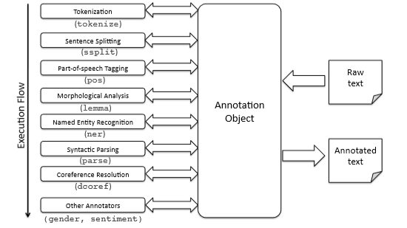

Architecture system: Raw text is put into an Annotation object and then a sequence of Annotators add information in analysis is pipeline. The resulting Annotation, containing all the analysis information added by the Annotators, can be output in XML or plain text forms.

Our pipeline system was initially designed for internal use. Previously, when combining multiple natural language analysis components, each with their own ad hoc APIs, we had tied them together with custom glue code. The Motivations were:
• To be able to quickly and painlessly get linguistic annotations for a text.
• To hide variations across components behind a common API.
• To have a minimal conceptual footprint, so the system is easy to learn.
• To provide a light weight frame work, using plain Java objects (rather than something of heavier weight, such as XML or UIMA’s Common Analysis System (CAS) objects).

Background
In 2006 the initial version of the annotation pipeline was developed in 2006 in order to replace this jumble with something better. A uniform interface was provided for an Annotator that adds some kind of analysis information to some text. An Annotator does this by taking in an Annotation object to which it can add extra information.
In 2008 An Annotation is stored as a type safe heterogeneous map, following the ideas for this data type.
In 2009 initially as part of a multi-site grant project, the system was extended to be more easily usable by a broader range of users. We provided a command-line interface and the ability to write out an Annotation in various formats, including XML.Further work led to the system being released as free open source software in 2010.

Elementary usage
A key design goal was to make it very simple to set up and run processing pipelines, from either the API or the command-line. An annotation pipeline can be applied to any text, such as a paragraph or whole story rather than just a single sentence.
The Stanford CoreNLP pipeline has been wrapped by others so that it can be accessed easily from many languages, including python, Ruby, Perl, javascript and other language.

Provided annotators
The annotators provided with Stanford CoreNLP can work with any character encoding, making use of Java’s good Unicode support, but the system defaults to UTF-8 encoding. The annotators also support processing in various human languages, providing that suitable underlying models or resources are available for the different languages.

Adding annotators
The information in an Annotation is updated in place (usually in a non-destructive manner, by adding new keys and values to the Annotation). it is quite easy to add additional custom annotators to the system.

Methodology

Presented the design and usage of the Stanford CoreNLP system, an annotation-based NLP processing pipeline.
Raw text is put into an Annotation object and then a sequence of Annotators add information in analysis pipeline step by step tokenization ,sentences splitting, part of speech, Morphological analysis ,named entity recognition, syntactic parsing, coreference resolution, other annotation (gender, sentiment) .The resulting Annotation , containing all the analysis information added by the annotators output in plain textforms. The backbone of the CoreNLP package is formed by two classes: Annotation and Annotator. Annotations are the data structure which holds the results of annotators. Annotations are basically maps, from keys to bits of the annotation, such as the parse, the part-of-speech tags, or named entity tags. Annotators are functions , except that they operate over Annotations instead of Objects. They do things tokenize, parse, or NER tag sentences. Annotators and Annotations are integrated by Annotation Pipelines, which create sequences of generic Annotators. Stanford CoreNLP inherits from the Annotation Pipeline class, and is customized with NLP Annotators.

Conclusion
In this paper, Presented the design and usage of the Stanford CoreNLP system, an annotation-based NLP processing
pipeline. We have in particular tried to emphasize the properties that we feel have made it successful. The goal has been to make it as easy as possible for users to get started using the framework, and to keep the framework small, so it is easily comprehensible, and can easily be used as a component within the much larger system that a user may be developing.

